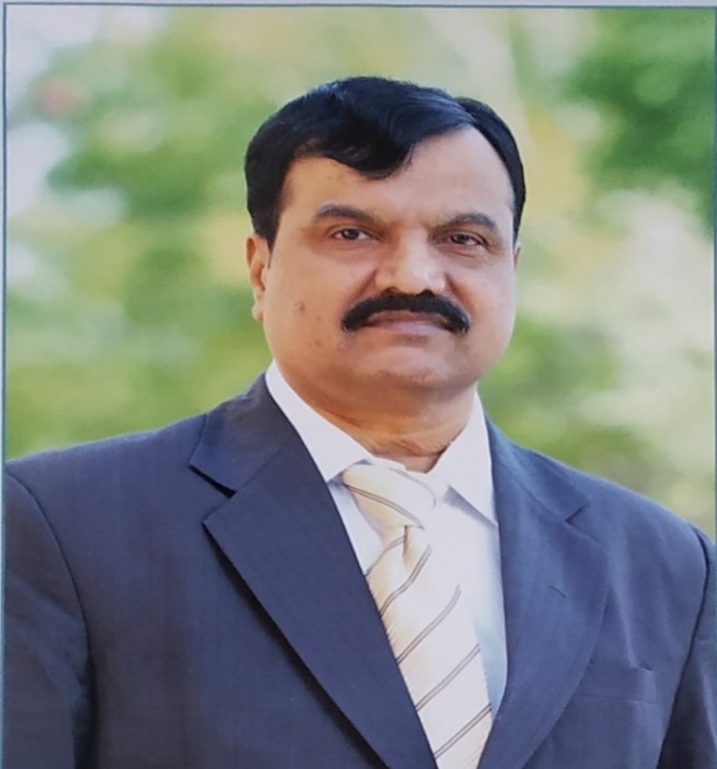

Dr. K GOVINDA RAJULU
M.Tech., Ph.D (IITR)
Principal &
Professor of Mechanical Engineering
Jawaharlal Nehru Technological University Anantapur
Anantapuram – 515 002, Andhra Pradesh, India

Profile at a Glance | Prof.K.Govindarajulu  Mobile:9908660033 ( P)  9000551425 (O)  Land : 08554 -273013  E-mail:principal.cea@jntua.ac.in(O)  govindjntu@gmail.com (P)
Residence Address  Flat No :201,6-3-197  Ramnagar  Anantapur 515004  Andhra Pradesh (India) | Official Address  Principal  JNTUA College of Engineering  Anantapur-515 002
PositionsHeld:

- Principal, JNTUA College of Engineering Anantapur
- Officer on Special Duty Anantapur
- Principal JNTUA College of Engineering Pulivendula
- Director of Evaluation Anantapur
- Director Foreign Affairs & Alumni Matters Anantapur
- Director, UGC Academic Staff College
- Officer on Special Duty Hyderabad
- Director of Evaluation Hyderabad
- Controller of Examinations Hyderabad
- Convenor, ECET ( FDH)
- Convenor, ECET ( FDH)
- Convenor, ECET ( FDH)

Achievements:
- Received “Best Teacher Award” by the Govt. of Andhra Pradesh
- Conducted ECET(FDH), a statewide Entrance examination of combined AndhraPradesh as convener for the years 2005, 2006 and 2007
- Acted as AICTE Hearing committee and AICTE Inspection committee member for granting permission to start new engineering college.
- Acted as expert in National Board of Accreditation committees
- Implemented world bank project ( TEQIP) worth Rs. 10.00 crores as Nodal officer
- As controller of Examinations, introduced and implemented EDEP (Electronics Distributions of Examination Papers) examination system in the University examinations in all the constituent and Affiliated Engineering Colleges of JNT University Hyderabad
- As Director, UGC Academic Staff College conducted several faculty development programs for the staff of university and affiliated colleges.
- As Director of Evaluation introduced online internal examination system
for all the constituent and affiliated colleges of the university.
- As Principal of the College organized several conferences and workshops for the students and several faculty development programs for teaching staff
- 101 Research papers in reputed journals and conferences
- Developed Infrastructure in JNTUA College of Engineering Pulivendula as Principal of the college.

Date of Birth: | 5th April 1960
Educational Qualification: | M. Tech., Ph.D. (IITR)
Professional Position: | Professor of Mechanical Engg (since 2000)
Administrative Position: | Officer on Special Duty (Since April 2018)
Teaching experience: | 33 + years teaching UG & PG students (since 1985)
Number of subjects taught: | 19 Theory subjects (UG & PG together)
Research experience: | 28 + years
No. of PG Theses: | 75 +
No. of Ph. D’s Awarded: | 11 and ( 02 under evaluation process)
No. of Ph. D’s in supervision: | 04
Research Publications: | International Journals 74  National Journals 04  International Conferences 19  National Conferences 21
Performance Indices of Publications: | Total Citations 436  h -Index 09  i-10 Index 13
Text Books / Monographs: | 01
Workshops / Seminars/ FDP Organized | 22
Attended | 11
I hereby declare that the information furnished is true to the best of my knowledge.

23.09.2019. (Dr. K.GovindaRajulu)

